**Abstract**

This project researched replicating the Bellcore fault injection attack on smart cards using CRT-based RSA. Smart cards are used for a variety of purposes, from being commonly used to make payments in Europe and elsewhere in the world to being used as identification cards in the U.S. by organizations including the Department of Defense. To create the faults an FPGA board replaced the signals to the card that would normally have come from the card reader. The goal of injecting faults was to create an incorrect signature that could be used to find the private key using the method of the Bellcore attack. If such attacks are possible, then the smart cards we tested are not secure and measures need to be taken to prevent such attacks. At this time, no faulty signatures that could be used to retrieve the private keys of the cards have been found through fault injection.

**Objectives**

The objective of the project is to test the security of smart cards, specifically Java Cards, against fault injection attacks on CRT-based RSA calculations. The project also seeks to understand the countermeasures that are being used, if there are countermeasures, against the attacks.

**Methods**

The method to carry out the fault injection attacks on the RSA operation was to replace the signals that would, in normal use, come from the card reader with signals from an FPGA board that we control. Before we started the attacks we used an oscilloscope and an extender board to measure the signals coming from the reader.

Measurements: We used an oscilloscope, an extender board, some wire, and a resistor to measure the power and clock signals the reader sends to the card when it is being used. The extender board connects the signals from the card reader to the card in such a way that they are more easily accessible for measurement or adjustment. To measure the voltage and current of the power being sent to the card as well as the voltage, current, and frequency of the signal being sent in the clock signal we cut the wires carrying the extender board’s clock and power signals and soldered wires to either side of the cut, we connected the wires to either side of a resistor and were able to measure the voltage drop across the resistor to find the current; the voltage we found by removing the resistor, connecting the wires and comparing the voltage across the wires to ground.

Picture of Extender board, reader, card, and wires(resistor not attached)

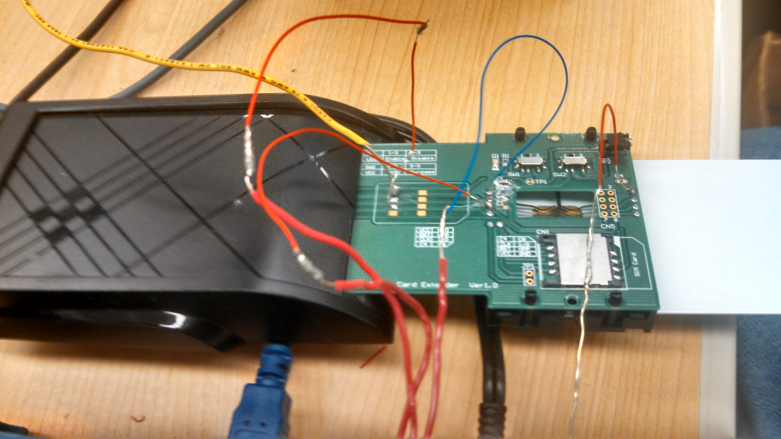

Fault Injection: Once we had the characteristics of the power and clock signals usually sent from the reader, we used Verilog to program an FPGA board to output those signals. We disconnected the wires on either side of the cuts in the extender board’s power and clock signals and connected the wires to the FPGA board. After the signal going to the card was being controlled by the FPGA board which we controlled, injecting faults was done by simply increasing the clock rate from the usual 4 mhz to 8 mhz or 16 mhz at a certain point after the signing operation began. The 8 mhz rate was used at the beginning of testing but was replaced by the 16 mhz rate when we realized that 8 mhz was within the range the coprocessor used by the card could be used at.

Picture of Fault Injection Set-Up Signals With Signals to Card Coming From FPGA

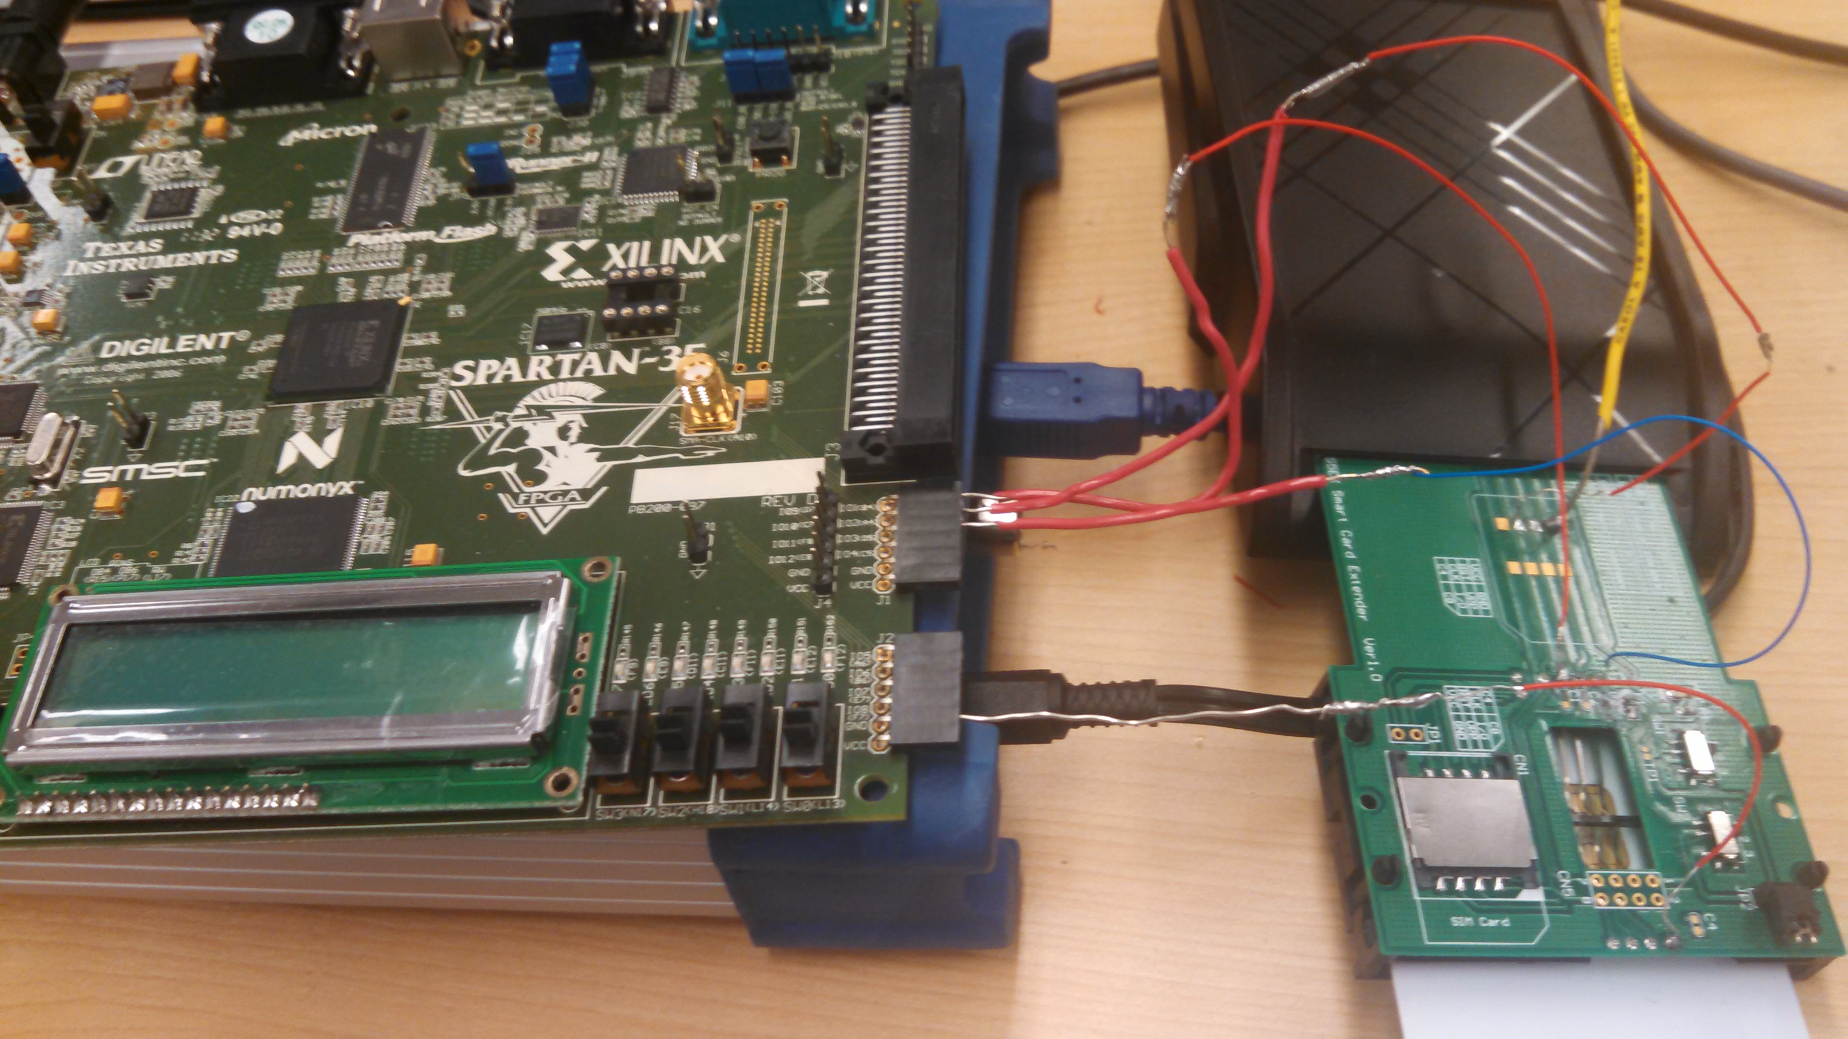

Testing: While the 8 mhz rate was being used, injections of faults between 1 million and 20 million except for 4, 7, 10, 13, 16, and 19 million FPGA cycle lengths were tested. An FPGA cycle is 20*10-9 seconds. We tested faults of those lengths at 4 million FPGA cycle intervals from the beginning of the operation until the end; for clarification, I injected the faults so that they started 4 million cycles later than the in the preceding test; I did not inject all the faults during one test, each fault was injected during its own running of the applet. After realizing that the 8 mhz rate was not fast enough, we switched to a 16 mhz rate and discovered that at that rate fault injections of around 100 FPGA cycles were long enough to sometimes prevent the applet from running; the applet was able to run successfully with faults of up to 15 million FPGA cycles when the 8 mhz fault rate was used. When we switched to 16 mhz we automated the testing and the amount of tests that were possible increased greatly. At the 16 mhz rate, we injected a fault of 100 FPGA cycles at 10000 FPGA cycle intervals from the beginning to the end of the signing operation; again, each injection took place in a separate running of the applet at a time 10000 cycles later than in the previous test. We also tried injecting the faults at 15,000 cycle intervals at the 16 mhz rate. We were able to produce incorrect signatures but all of the incorrect signatures were wrong in the same way, they were missing their last 32 hexadecimal characters or their last 128 bits; those signatures could not be used to find the private key using the Bellcore attack’s method. We also tried injecting 90 and 110 cycle faults but did not test as many because they produced fewer faulty signatures.

During the automated testing we switched applets twice. The first applet could only produce signatures; the second applet could output a signature or the public key for verifying the signature outside of the applet; and the third could produce a signature, the public key, or the components of the private key in CRT form. Each time we switched signing applets the timing of the applet changed and the previous testing had to be repeated.

The Verilog code that was controlling the FPGA board and the Java Card Applet can be found at the end of this report.

**Results**

Our testing did not produce any incorrect signatures that could be used to factor the modulus of the RSA key. We also noted that injecting a fault in different places did not always produce the same result.

**Conclusions**

Our not finding any usefully incorrect signatures could either mean that there are countermeasures in place that successfully prevent fault injection attacks, as the manufacturer of the coprocessor claims, or it could mean that our testing and methods needed to be changed to produce incorrect signatures that we could use to find the private key. Some countermeasures that may be in use on the cards are to check the correctness of the signature at the end of the operation, to monitor the incoming signals and end the applet if they are incorrect, and to introduce random delays into the operation in order to prevent fault injection attackers from timing their attacks consistently. It seems unlikely that the signatures are being checked at the end because we were able to cause incorrect, if also un-useful to us, signatures to be outputted. The fact that injecting faults in the same place during successive runs did not consistently produce the same result suggests that there is some sort of random delay being introduced somewhere into the running of the applet. Also, it is possible that the card is monitoring the incoming clock signal with an internal clock; this could be supported by the fact that the applet could be caused to stop before it would normally finish by injecting a quickened clock signal.

**Verilog and Java Code Used**

Links with Easier to Read Formatting:

-The Java Card applet can be viewed with proper formatting at this link: <http://pastebin.com/jhSgztKk>

-The Verilog code used to control the FPGA board can be found with easier to read formatting at this link: <http://pastebin.com/XpGJ2ir3>